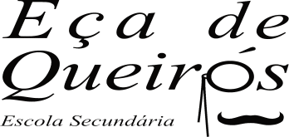
ESCOLA SECUNDÁRIA EÇA DE QUEIRÓS
Departamento de Língua Estrangeira
English

HOLIDAYS - PLACES AND DESTINATIONS (Speaking Activity) Teacher: Teresa Rafael

Name: Pedro Aurélio Class: S - 13

- Developing Vocabulary -
- Identify the buildings you see and name where one can find them.
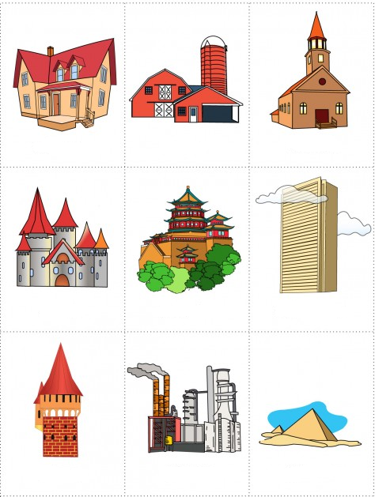

We can find a house in a village.
We can find a barn in the countryside.
We can find a church in a village.

We can find a skyscraper in cities in the U.S.A.
We can find a castle in Lichtenstein.
We can find a temple in China.

- b)

We can find a tower in a palace.
We can find a factory in cities.
We can find pyramids in Egypt.
a tower pyramids a factory a church

a castle a temple a skyscraper a barn
a house
Egypt cities Palace
countryside China U.S.A
Lichtenstein villages

